Assignment 9:
1. What is Foreign key relationship?
-> A foreign key relationship is a connection between two tables where a field in one table refers to the primary key of another table. It ensures data integrity by allowing only valid values that already exist in the referenced table.
Or
(A foreign key relationship links two tables to maintain data consistency and integrity.)

2. Create Foreign Key between 2 Table & Each table should've 5 fields.
-> First open ABAP Dictionary by entering Transaction code SE11.
Create a table by entering a name and name should starts with Z(ZDEPT).
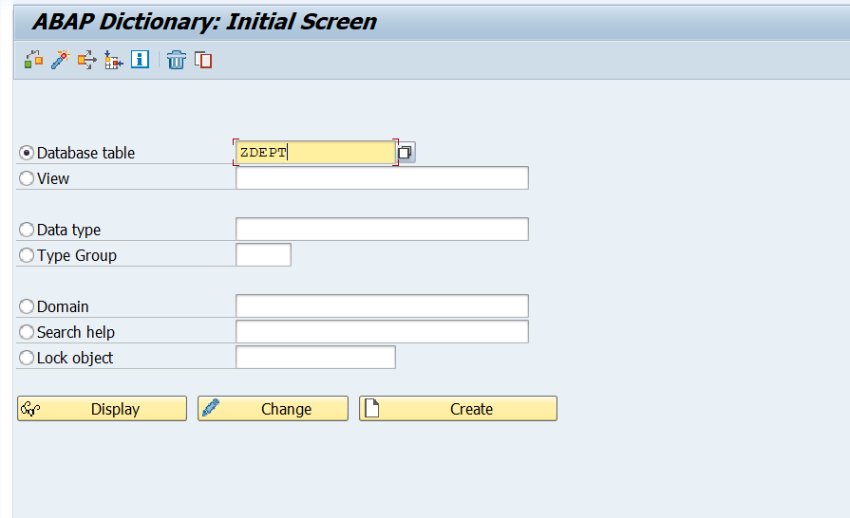
->Create a domain(ZDEPT_DOM):
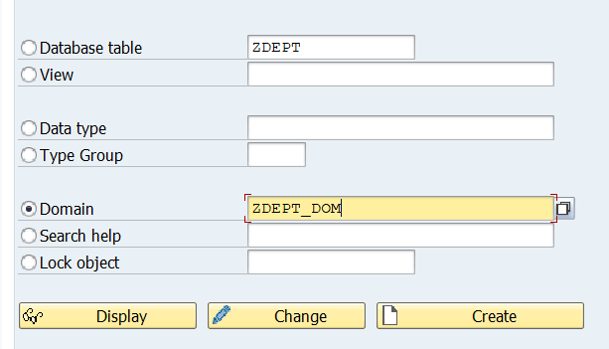
->After creating Domain define the Datatype and Activate the Domain (ctrl+s),(ctrl+f2), (ctrl+f3).
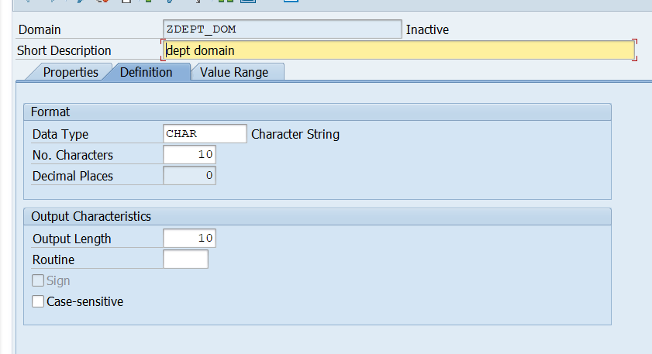
->Next create the data element: (Datatype->Domain name->Double click on domain
name->define datatype->activate it)

->Add Data class as APPL0: and size category 0.
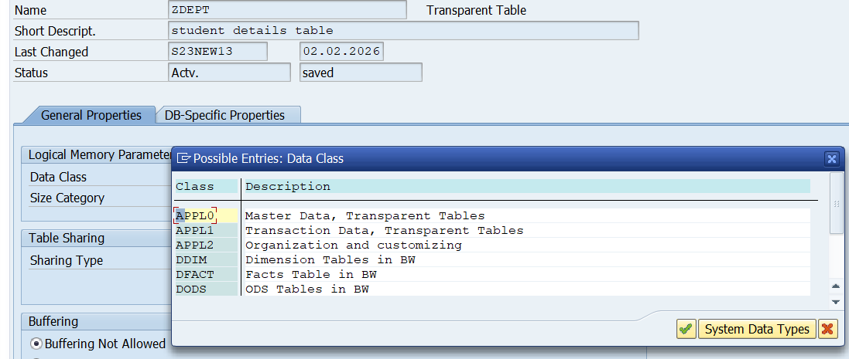
->Choose Delivery Class A - Application table (master and transaction data)

->Choose Display/Maintenance Allowed and continue.
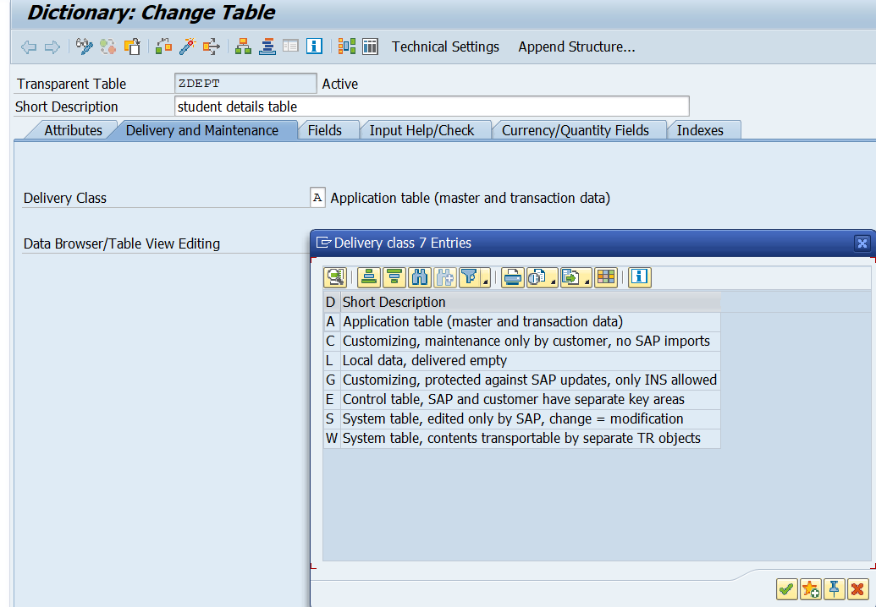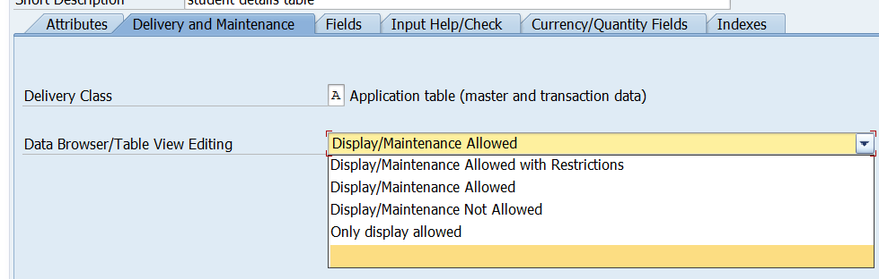

->In the fields tab define dept_id(primary key),dept_name,dept_location
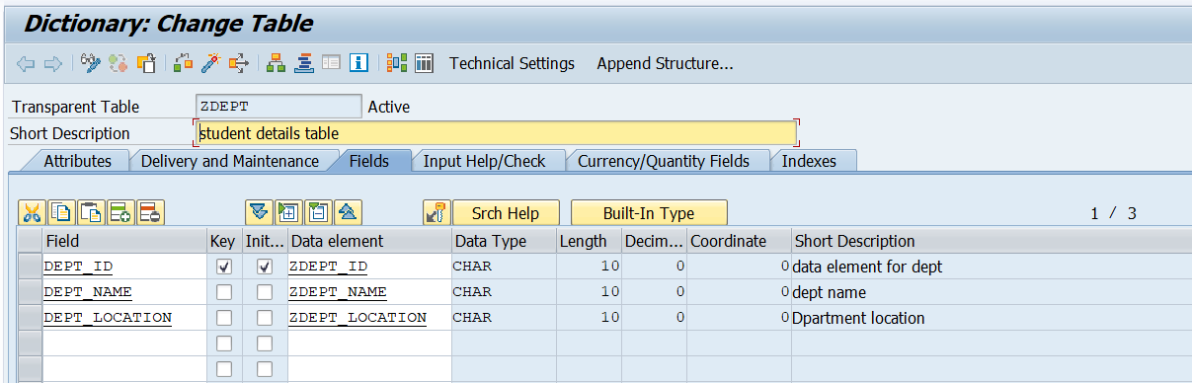

After defining all fields save the table (ctrl+s), check the table(ctrl+f2),and Activate the table(ctrl+f3).
*DEPT Table acts as a check table.

->Create Student table as ZSTUD: with field names STUDENT_ID(PRIMARY KEY),STUDENT_NAME,STUDENT_BRANCH,AND DEPT_ID(FOREIGN KEY).
->Domain name for DEPT_ID(Foreign key) should be same as DEPT_ID(Primary key) from department table
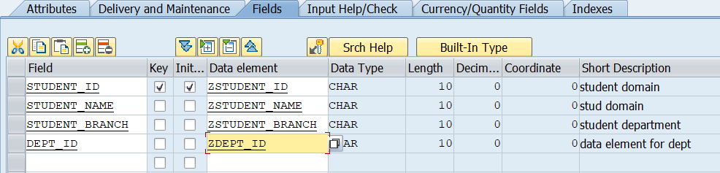
->Save the table (ctrl+s), check the table(ctrl+f2),and Activate the table(ctrl+f3).
->Assign the foreign key Relatioship:
To assign foreign key ,select the DEPT_ID field in the STUD table and click on Foreign Key button
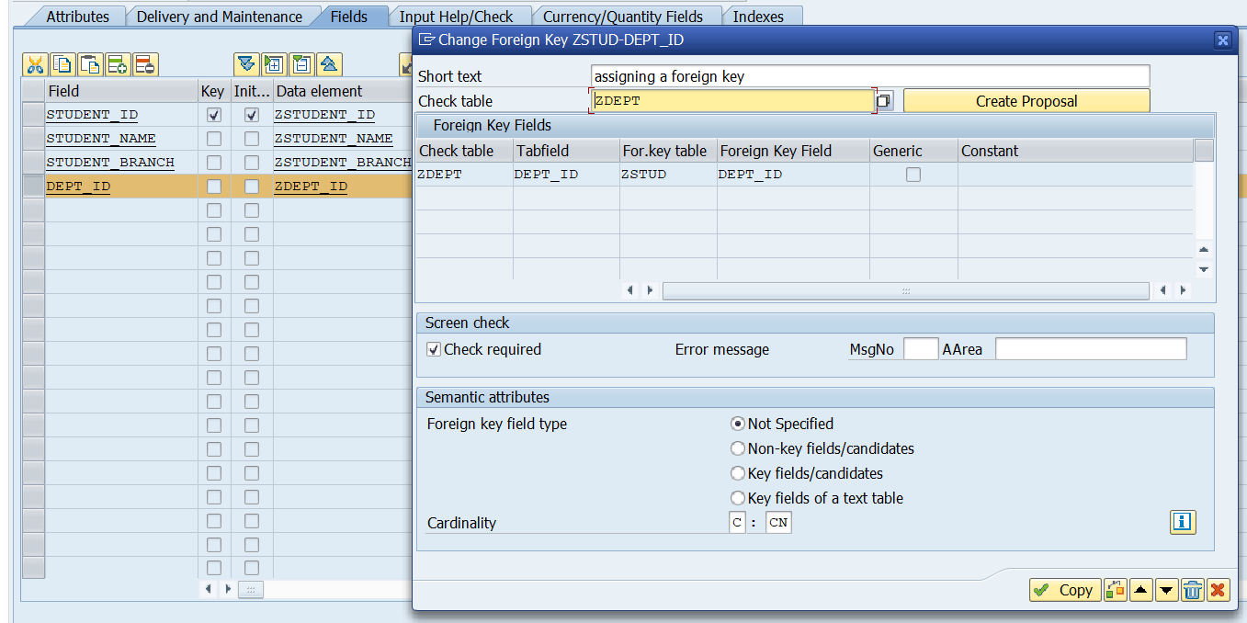
->And choose Cardinality C:CN and Click Create Proposal
The system automatically proposes the field relationship between ZSTUD-DEPT_ID and ZDEPT-DEPT_ID. Save the table (ctrl+s), check the table(ctrl+f2), and activate the table(ctrl+f3).
->Create entries to the DEPT table:
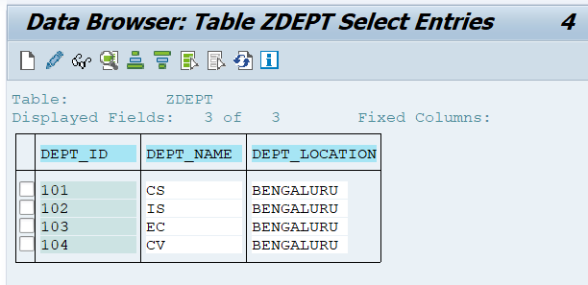
->Create entries to STUD table:
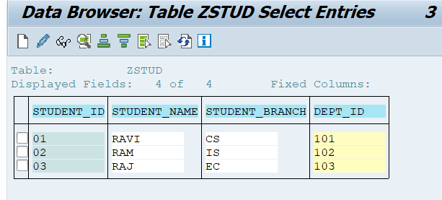
->After assigning the foreign key, the system ensures that only valid department IDs from the DEPT table can be entered in the STUD table (DEPT_ID).
If a department ID does not exist in the DEPT table, the system will not allow it to be saved in the STUD table.
3. What is value table and its uses?
-> A value table is a table that provides a list of valid values for a field. It is linked to a domain in the Data Dictionary and helps control what data users can enter.
(A value table defines the set of valid values that a field can accept.)
Uses:
- Restricts incorrect data entry
- Improves data consistency
- Provides dropdown/input help
- Acts as a reference for foreign keys
4.Difference between check & value Table?

->A check table is used to validate the values entered in a foreign key field. It ensures that the value entered in a field exists in another table. When a user enters data, SAP checks the check table to allow or reject the value. Check tables mainly help in maintaining data consistency and integrity.
*A check table controls what values are allowed
*A check table works during data validation
*A check table is defined through a foreign key relationship
*Field level validation
->A value table is used to provide possible values (F4 help) for a field. It suggests a list of allowed values to the user while entering data. Value tables are mainly used for input help, not for enforcing strict validation.
*Value table helps the user choose a value.
*Value table works during data selection
*Domain level validation.

5.What the use of Foreign Key summary?
->The Foreign Key Summary is used to display and manage all foreign key relationships of a table in one place
It shows which fields of a table are linked to which check tables
Foreign key summary helps developers understand table relationships quickly without opening each field individually.
Using the foreign key summary, we can create, change, or delete foreign keys and also check details such as cardinality, check table, and field mapping.

7.When we've 10 records in check table & when we try to add 11th records in item table what will happen?
->If there are 10 records in the check table, it means there are 10 valid master values.
When you try to insert the 11th record into the item (foreign key) table, SAP does not restrict the number of records in the item table.
The system only checks the foreign key field value, not the record count.

